Italian Wine Month
Italian Sparkling — by the glass
NV Astoria “Butterfly” Prosecco Extra Dry Treviso 17 / 74
A joyful opening to the experience—lively and fragrant, with notes of tropical fruit, banana cream and a soft hazelnut finish that lingers just long enough.

Italian Whites — by the glass
2022 Madonna del Cariano Bianco Corvina Bianco Verona 18 / 82
From the hills of Verona, this wine speaks in lifted aromatics—jasmine, apricot and sun-ripened peach—capturing the warmth and charm of northern Italy.
2024 St. Michael-Eppan Schulthauser Pinot Bianco Alto Adige 28 / 124
Cool alpine precision defines this wine. Mineral and composed, it unfolds with dried herbs and pristine white fruit, reflecting the clarity of its mountain origins.
2022 Sedilesu Granazza Sardinia 18 / 76
A rarer expression from Sardinia—textural and intriguing, with hints of caramel, dried flowers and a gentle rustic edge that invites contemplation.

Italian Reds — by the glass
2021 Cascina Chicco Barolo Rocche di Castelletto Piemonte 44 / 210
A classic voice of Piemonte—perfumed and structured, where spice, blue florals and wild berries weave together with a subtle note of licorice.
2017 La Serena Brunello di Montalcino Sangiovese Tuscany 56 / 248
Time has shaped this wine beautifully. Layers of dark cherry, plum and blood orange are framed by dried herbs and fine leather—an elegant partner to a perfectly prepared bistecca.
2021 Varvaglione Papale Oro Primitivo di Manduria Puglia 36 / 180
Rich flavors of dark fruits and spices, making it an excellent choice for pairing with red meats and hearty dishes.
2020 Tignanello – Antinori Sangiovese Tuscany 130 / 720
An icon in its own right. Powerful yet refined, it delivers concentrated forest fruits, sculpted tannins and vibrant acidity, culminating in a long, resonant finish.
Italian Dessert wines — by the glass
2024 Braida Brachetto d’Acqui Piedmont 18 / 72 (375ml)
Playful and aromatic, this gently sparkling red offers notes of plum, cherry and raspberry—light on its feet, yet full of charm.
NV Marchesi di Barolo Barolo Chinato Piedmont 18/120 (500ml)
A contemplative close—Nebbiolo enriched with botanicals and spice, creating a deeply aromatic and lingering digestif.

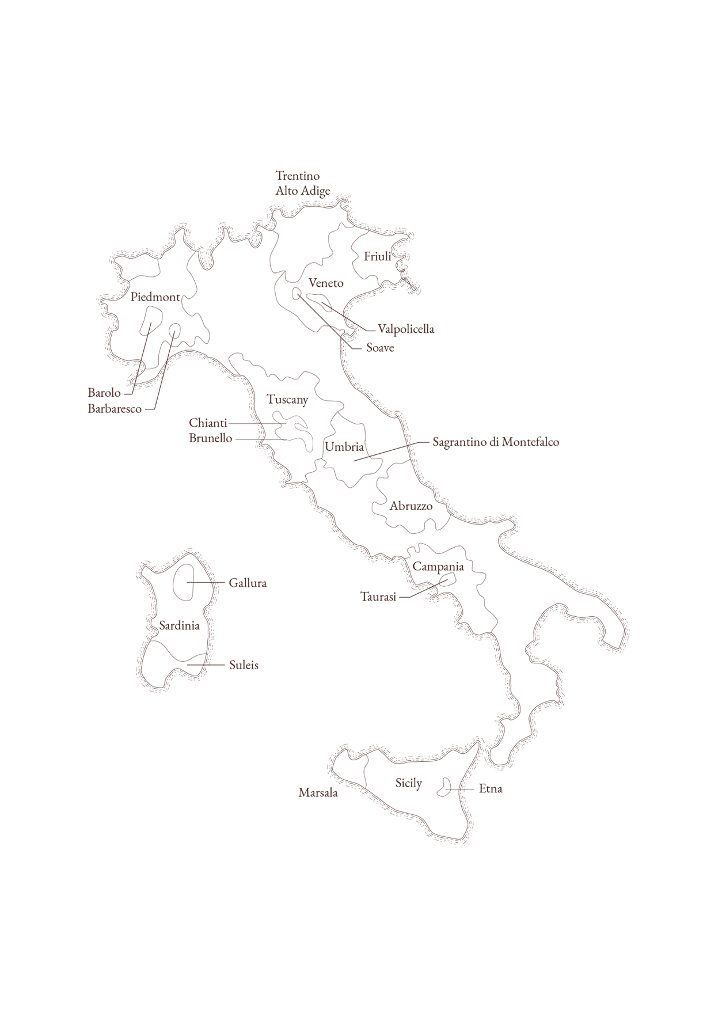
ITALY
Wine RegionS

